Monitoring / On-Call Approval Form

Employee Name: Nikunj Adhaduk _

Manager Name: Vlad Rabenok .
Monitoring Hours
Date of Monitoring (mm/dd/yyyy) | Project | Reason | Number of Hours
04/8/2023 | Scene+ | Cosmos issue started so on call with ITOPS and BTS to analys this issue and ultemetely found it was issue from MS side where due to their internal deployments | 6 hours in total  Call at 3 PM, 6.30 PM, 8 PM
04/09/2023 | Scene+ | Support request Id: 2304080010000253 | 1.5 Hours in total  To explain MS engineer about entire issue
04/10/2023 | Scene+ | Support request Id: 2304080010000253 | 3 hours in total  After hours call with MS started at 7.30 then another at 11.00 PM to give entire query list to MS
04/16/2023 | Scene+ | Support request Id: 2304080010000253 | 2.5  Testing and update with MS after fix from their side
04/22/2023  04/23/2023 | Scene+ | Support request Id:  2201140040006553  Also, cosmos issue again and had to reach out to MS engineer where query charge spike again and MS made further changes on their end and also suggested index change on our side for query | 3 Hour  Call at 10 AM, 4 PM
04/24/2023 | Scene+ | On call with Developer for missing event issue  And testing and provided asking information on MS open ticket regarding cosmos. | 2 Hour
TOTAL |  |  | 18

On-Call Payment
Dates On-Call (mm/dd/yyyy – mm/dd/yyyy) | # of Weeks | Rate
 | 1
 | 1
 | 1
 | 1
 | 1
TOTAL

Approvals
Employee Signature:  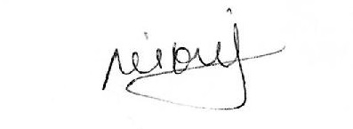 | Date:  8 May 2023
Manager Signature: | Date:

Please submit to Payroll once approved.

